Github with notebook (needs to be a little bit edited): https://github.com/jorgesandoval/iotthreat-classification-ensemble/tree/main
Dataset:
http://cicresearch.ca/IOTDataset/CIC_IOT_Dataset2023/Dataset/

I have used a subset of the database with only the following floods. I have done an script to generate a new csv with only the benign or mirai attacks:
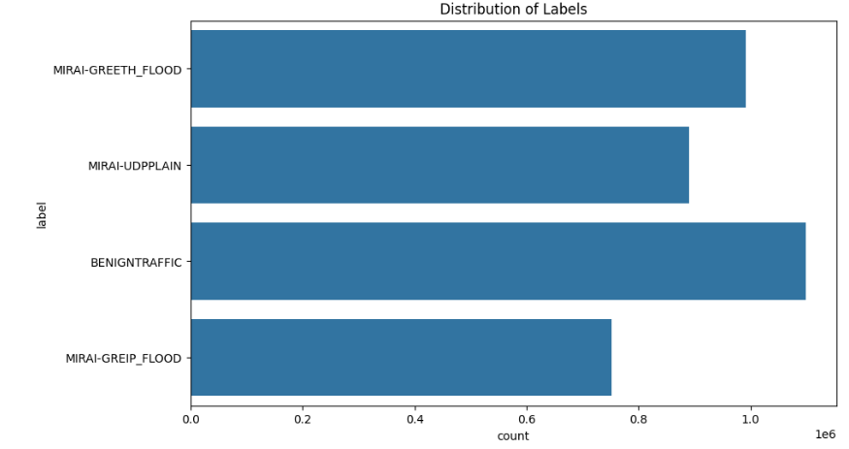

These are the results:

